Scenario

You are using SharePoint Online for your intranet portal. You have put a lot of effort into it and created a nice news page. Now, you want to use a similar layout/template for all other upcoming news, or you want to make this template available for others. This will save a lot of time recreating, repositioning sections, and making web parts. Well, how to do that? Let’s see.

Solution

It’s an easy solution. Whenever you create any page, you get an option to save it as a draft or save it as a template. How does a page template work? Where does it get stored?

Well, when you save a page as a template, it gets stored in the “Templates” folder in site pages library of the same site. It is available to all users who have contribute permission on the site. They can use it and create a new page. You can then modify the page as per the requirement. It won't impact the original template.

Can I modify or update the template? Yes, you can modify or update the template easily. Keep in mind, It will not affect the pages which are already created using this template.

How to create a Page Template

Open your SharePoint Online site.

From the home page, click on New >> Page.

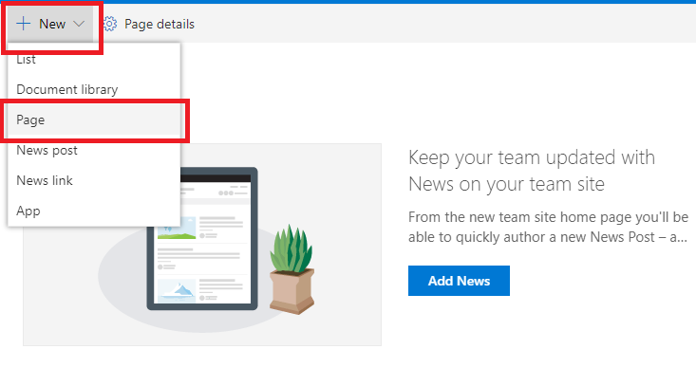

On the next screen, select “Blank” template and click on “Create Page”.

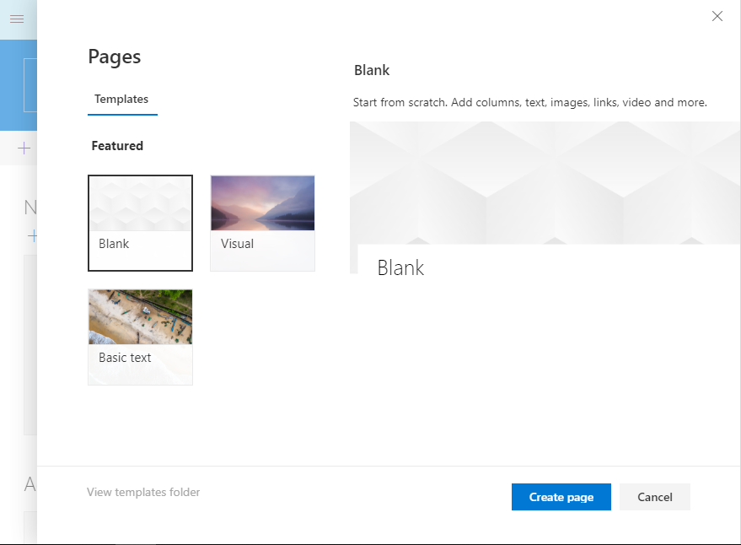

OR from Settings icon, click on "Add a Page".

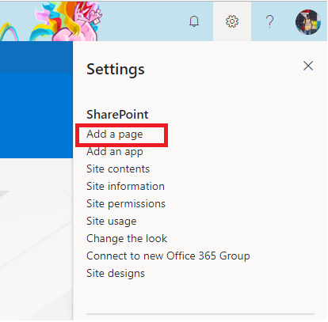

Provide a title for your page, and set a nice background image to the title section. Add the required sections and web parts on your page. Choose sections with single/two/three columns layout, add required web parts like a Text editor, Image, Image Gallery, List, Documents, Highlighted content, etc.

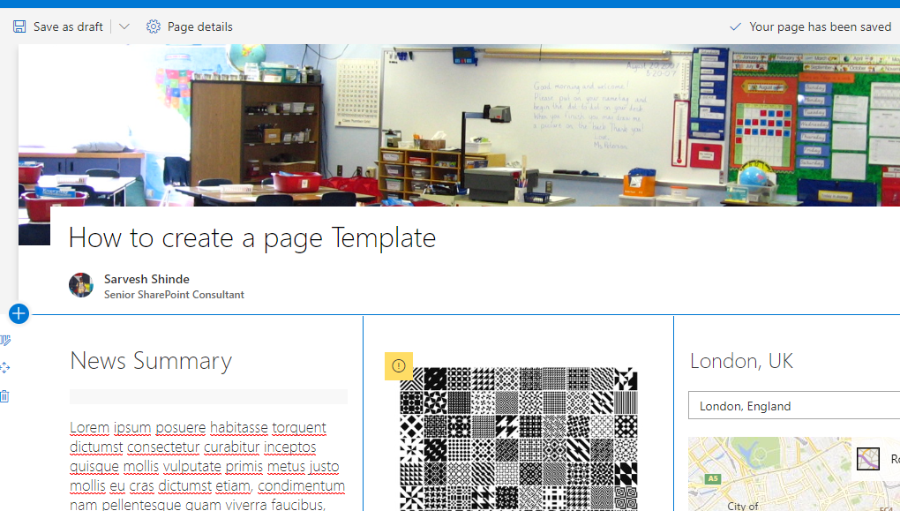

Once you are done with your page creation >> *click on down arrow* beside Save as Draft >> Select “Save as template” >> This will save your current page with all sections and webparts as a template

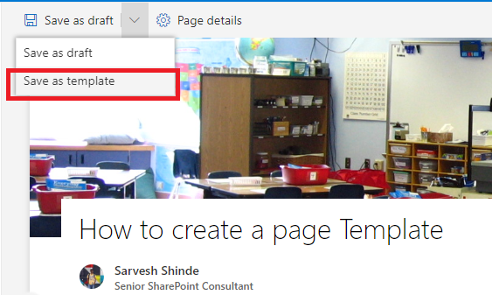

Give a name to the template and click on “Save page Template” button

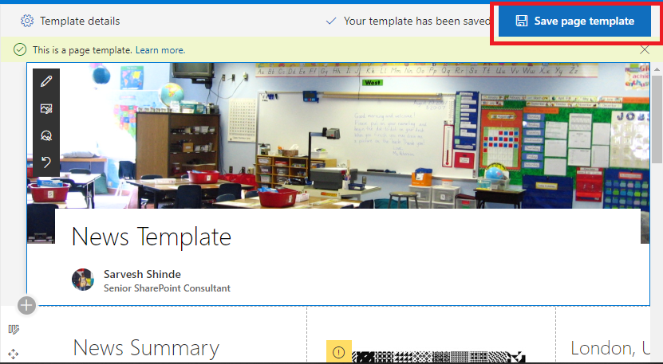

Now if you navigate to Site Pages library of your site >> you will find a Templates folder is created in it >> if you open the folder, you will see that your page template is stored over there.

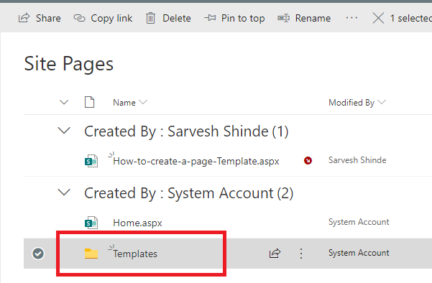

You can open the template any time from this location, you can delete it, you can update it, you change the template name.

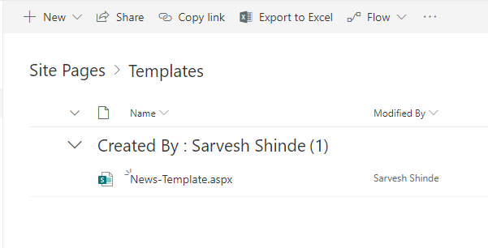

1. How to use Page Template

Let’s see how to use the page template now. As mentioned above there are different ways  you can create a page in a site,

1. From the new button on the home page
2. Settings icon and add a page
3. Directly from Site Pages library
4. From news webpart.

**Note**If you want to use a template while creating a page then it works only with first option mentioned above.

Go to home page of your site >> Click on New button on command bar >> Select Page



You will see your recently added template with its title and layout. Select it and click on "Create a page".

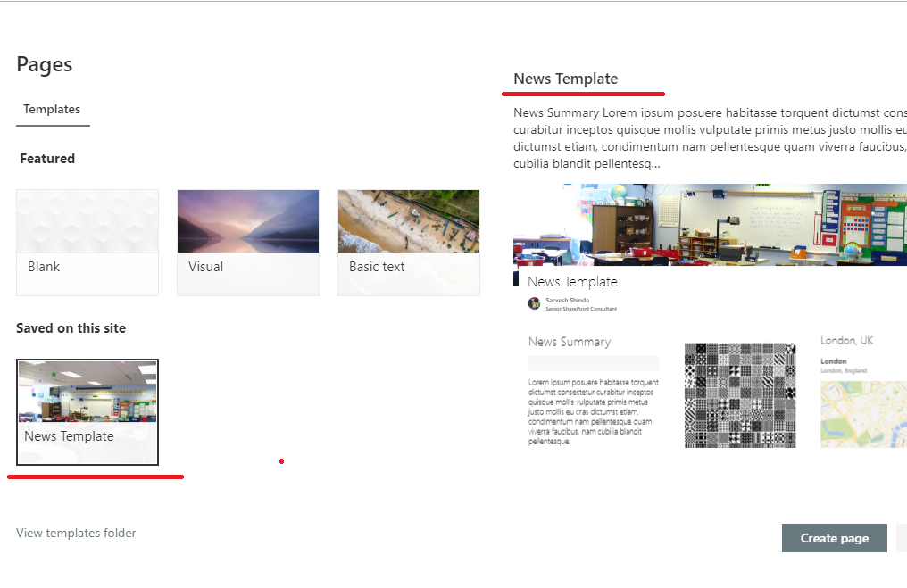

You can update the content of the new page now, you can remove web parts – add new web parts, add sections or modify it. This will not impact the saved template.